{Date}

Dear {honoree’s name},

On behalf of Multiplying Good’s Students In Action team at {name of school/organization}, we are honored to announce that you have been chosen to receive a Multiplying Good Certificate of Excellence for your outstanding service to our community.

Multiplying Good was founded in 1972 by Jacqueline Kennedy Onassis, U.S. Senator Robert Taft, Jr., and Samuel S. Beard with a mission of cultivating greatness through service to others. The Multiplying Good Certificate of Excellence is among America’s most prestigious honors for those individuals committed to making a difference, and you are among now among a storied group of recipients nationwide who have been celebrated for their commitment to community.

{Name of school’s/organization’s} Students In Action team would like to recognize your outstanding efforts, which include, {briefly list the honoree’s efforts here}.

At Multiplying Good, we believe in public service not just because it improves communities, but because it changes the lives of those who participate. We believe so strongly in the power of public service that we promote it every way we know how. Since 1972, we have honored over 63,000 grassroots unsung heroes and trained over 35,000 young people to lead a life of servant leadership.

Please join us on {date and time of ceremony} at {location of ceremony} so we may honor you with this prestigious award. We also encourage you to bring your family and friends to witness this unique and special occasion!

To let us know that you will be able to attend the ceremony or should you have any questions or concerns, please feel free to contact {name of school’s/organization’s} Students In Action President, {name of team president} at {president’s contact information}. Congratulations once again on receiving this prestigious award.

Sincerely,

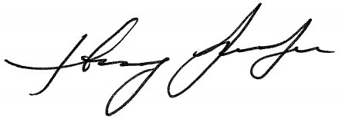
Hillary Schafer {Name of School/Organization}
CEO Students In Action

